IDE Setup

Installation
Install VSCode https://code.visualstudio.com/
Within VSCode Install C++ Pack extension
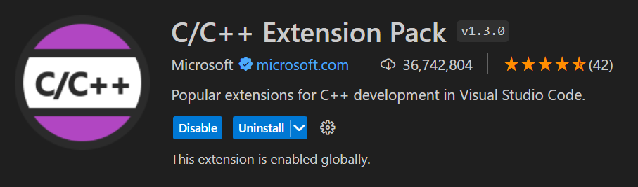
Install ESP-IDF extension
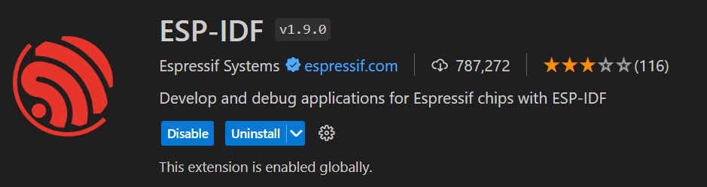

Warning
IDF_PYTHON_ENV_PATH should be undefined. If you ran the standalone ESP IDF tools installer, this value will be defined in your system’s user variables and will need to be removed.

Configuration
- F1 -> ESP-IDF: Configure ESP IDF Extension
- Install v5.3.2 (release version) with default settings and paths
- If you ever use another version you will need to update all the tool paths in .vscode/settings.json

Project Creation
- F1 -> ESP-IDF: New Project
- Select 5.3.2 framework
- Name your project and choose a location
- Choose ESP32-S3 chip (via builtin USB-JTAG)
- Select Choose Template
- Select dropdown and select ESP-IDF instead of extension
- Choose a template and select "Create project using template"
- It will prompt to open the project in a new window, do so.
- Trust the authors of the workspace

Project Configuration
- F1 -> Set Espressif Device Target
- Select esp32s3
- Select ESP32-S3 chip (via builtin USB-JTAG)
- Drop the contents of ESP_IDE/Include folder into top level project folder
- Drop partitions.csv from ESP_IDE/Include folder into top level project folder
- Right click sdkmenu and select SDK Configuration Editor
- Set CPU speed to 240MHz
- Set Flash Size to 8MB
- Compiler optimization level should be -Og (-O0 has less debug information)
- For Partition Table Select Custom Partition Table, it should reference partitions.csv by default
- You may wish to increase rtos tick from 100 to 1000Hz
- You may wish to disable watchdogs depending on task structure of your program
- Save settings
Project can be built with Ctrl + Shift +B
Debug can be started with F5, it will also build and flash the project before starting the debug session.
UART monitor can be started by clicking the monitor icon in the bar 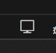. This will restart the ESP but will maintain the debug connection if you have it open.
Install USB driver if you haven’t already (see Driver Install section)

Driver Install
The ESP USB interface is a composite device. By default Windows installs its own driver that doesn’t work for debugging and uart output. We need to install the Espressif driver and any time we plug in a new ESP we need to manually update the driver Windows uses.
Run this in powershell to install USB driver
Invoke-WebRequest 'https://dl.espressif.com/dl/idf-env/idf-env.exe' -OutFile .\idf-env.exe; .\idf-env.exe driver install --espressif

Driver Verification
When ESP is plugged in, in Device Manager it should show up under "Universal Serial Bus devices" as "USB JTAG/serial debug unit"
Under Properties / Driver it should have a driver provider by libwdi.
If it says Microsoft you need to update the driver manually.

Driver Update
Click Update Driver -> Browse my computer for drivers -> Let me pick from a list of available drivers on my computer -> USB JTAG debug unit

Antivirus Exclusion
Run the following in powershell to decrease build times
Invoke-WebRequest 'https://dl.espressif.com/dl/idf-env/idf-env.exe' -OutFile .\idf-env.exe
.\idf-env.exe antivirus exclusion add --all
To unregister the exclusions you can run
.\idf-env.exe antivirus exclusion remove --all

